**DojoOverflow Assignment**

In this tab, you will be creating a StackOverflow / Quora clone. Users will be able to create questions, answers, and add tag subjects for the questions.

ERD and Wireframe

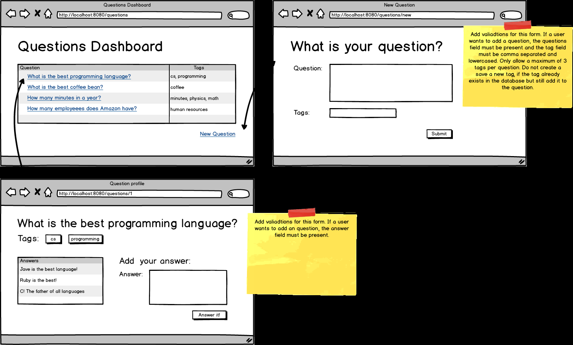

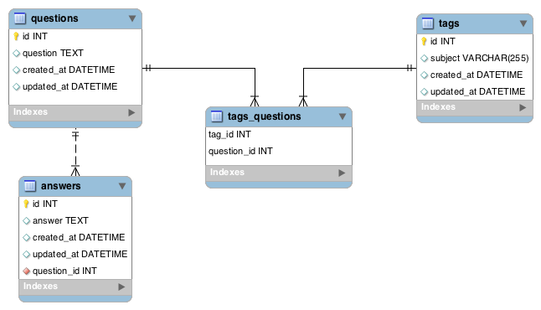

Topics:

* Relationships
* Validations
* Domain Models
* JPA methods

Tasks:

* Have the question dashboard display each question and their tags.
* Allow users to create questions with tags and implement validation errors.
* Allow users to answer questions and implement validation errors.
* Have the question show page display all the answers for that specific question.